**Work Breakdown**

All Listed Tasks and Features completed By - **Michael Anetor – N01296956.**

**Database design and Implementation**

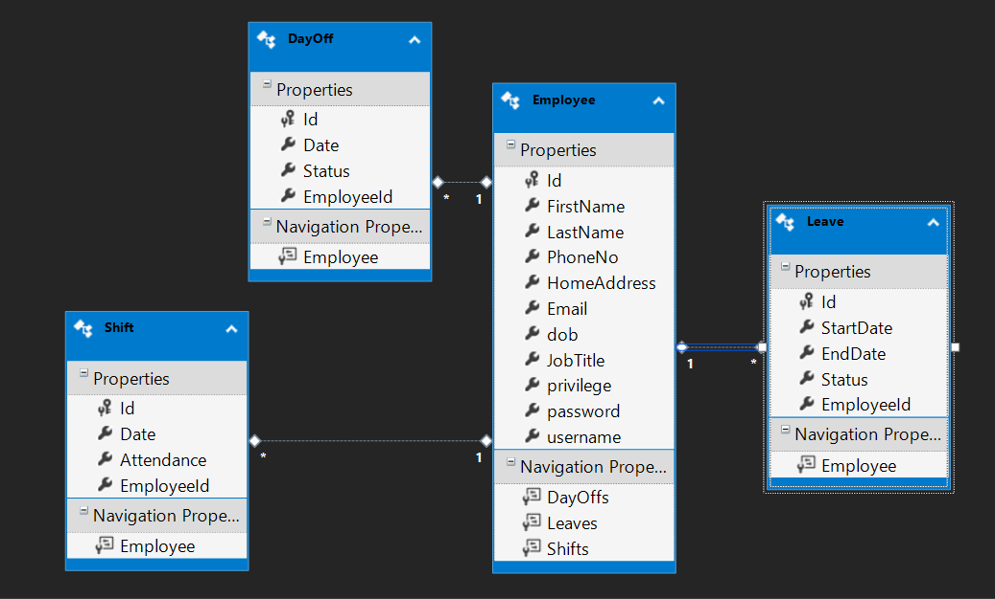

**Controller Scope:**

Home Controller

Employee Controller

Administrator Controller

Leave Controller

Shift Controller

Day-Off Controller

**Page Scope:**

Login page

About us and Contact Page

Employee page

Administrator page

**EMS Operation Flow**

* **The home controller** provides navigation to the login page, contact page, and about page.
* Application begins from the **login page** in the home controller.
* User input username and password.
* Upon a validated user entry, the system checks if user is an admin or a user, and also checks that the username and password conforms as in the database.
* **If – client privilege is User**
* The **Employee controller** is called and then redirects to the employee Home page which requires a username parameter injected to retrieve and load the user specific data into the application.
* The **employee details page** - employee can view personal information and assigned shift dates.
* The **editDetails page** - allows employee to modify changeable personal information
* User can access employee bound pages through the navigation bar.
* The **dayOff page** - shows list of assigned shifts for the employee to pick which one to choose as a day off
* The **vacation page** - shows list of assigned shifts for the employee to pick which one to choose as a day off
* The **request page** -Provides employee the choice of making a day-off request or a vacation request, as well as displays all day-off and vacation requests with their status whether pending, approved, or refused.
* The **schedule page** –Displays Information such as :

- Employee shifts.

- Statistics regarding employee performance.

**If – client privilege is Admin**

* The **Administrator controller** is called and then redirects to the admin Home page which requires a username parameter injected to retrieve and load the user specific data into the application.
* The **admin profile page** - admin can view personal information.
* The **edit details –** admin can modify own profile information.
* Onclick of the Employee Manager link, the **employeeList Controller** and the admin can perform **CRUD** operation on employees. Also the employee has the search, pagination, and sort (by name and job title) feature to easily navigate through the employee list.
* The other links available on the Employee manager page provides access to the **Leave Controller, Shift Controller** and **Day-Off Controller**, which the admin can use to perform **CRUD** operations on **the leave page, shift page** and **day-off page** respectively.